Monitor Cluster Components:
how do you monitor resource consumption on Kubernetes? Or more importantly, what would you like to monitor?
I'd like to know node level metrics, such as the number of nodes in the cluster, how many of them are healthy, as well as performance metrics such as CPU, memory, network, and disk utilization, as well as pod level metrics such as the number of pods and the performance metrics of each pod, such as the CPU and memory consumption on them.
So, we need a solution that will monitor these metrics, store them, and provide analytics around this data. As of this recording, Kubernetes does not come with a full featured built in monitoring solution. However, there are a number of open-source solutions available today, such as Metrics Server, Prometheus, Elastic Stack, and proprietary solutions like Datadog and Dynatrace.
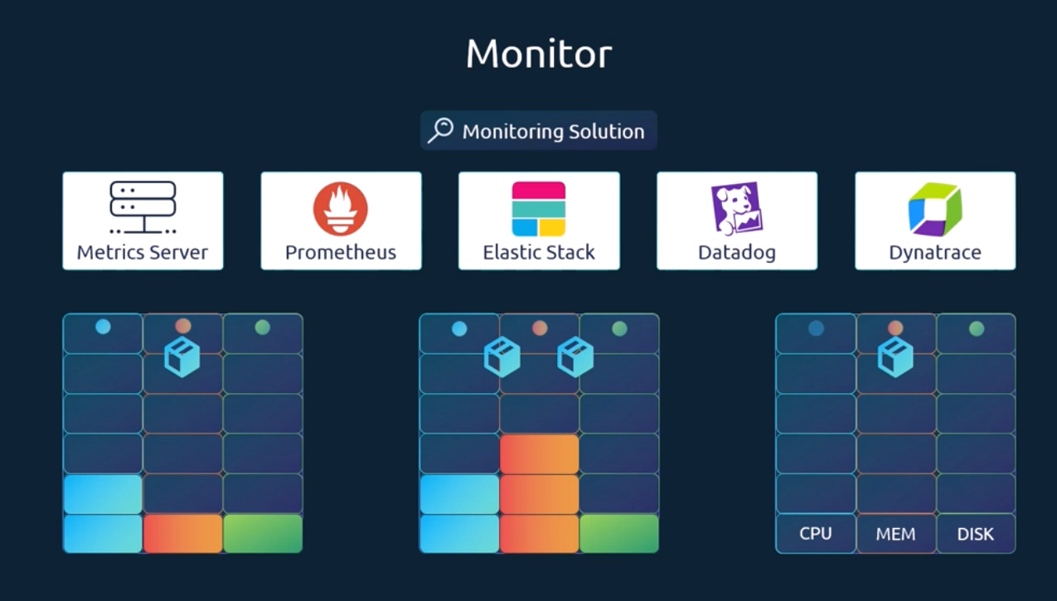

Hipster was one of the original projects that enabled monitoring and analysis features for Kubernetes. You will see a lot of reference online when you look for reference architectures on monitoring Kubernetes. However, hipster is now deprecated and a slimmed down version was formed, known as the Metrics Server.
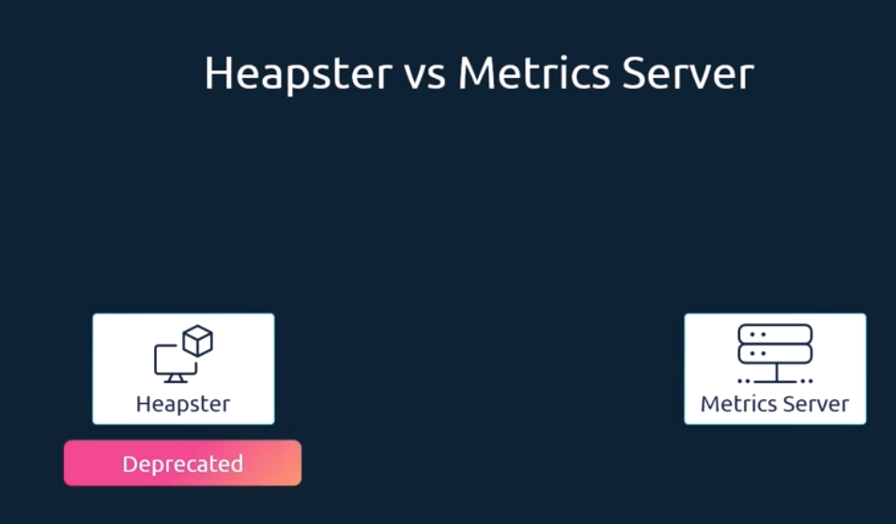
You can have one metric server per Kubernetes cluster.
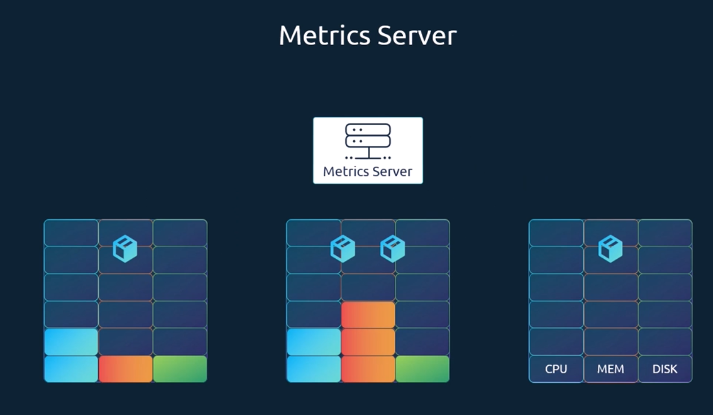
The metrics server retrieves metrics from each of the Kubernetes nodes and pods, aggregates them, and stores them in memory. Note that the metrics server is only an in-memory monitoring solution and does not store the metrics on the disk, and as a result, you cannot see historical performance data.
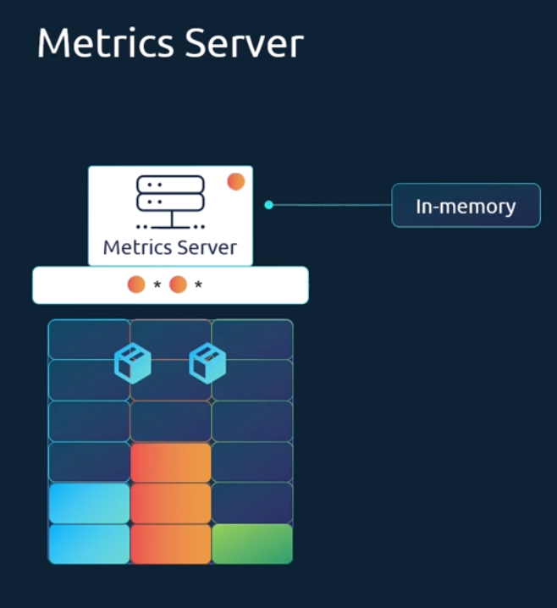
For that, you must rely on one of the advanced monitoring solutions we talked about earlier in this lecture. So how are the metrics generated for the pods on these nodes? Kubernetes runs an agent on each node known as the Kubelet, which is responsible for receiving instructions from the Kubernetes API, master server, and running pods on the nodes. The Kubelet also contains a subcomponent known as the C advisor or Container Advisor. C advisor is responsible for retrieving performance metrics from Pods and exposing them through the Kubelet API to make the metrics available for the metrics server.
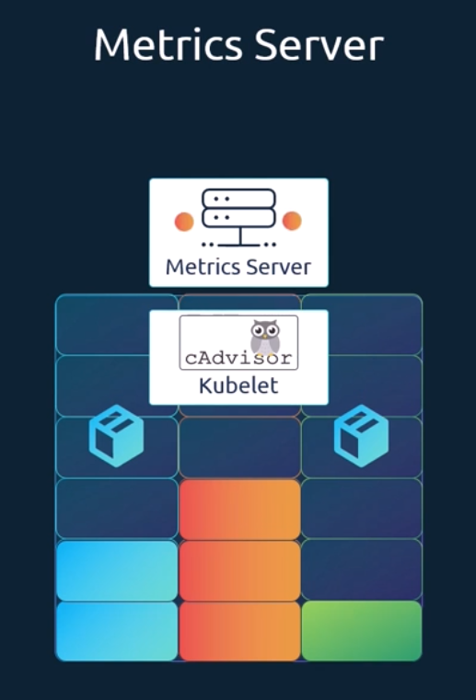
If you're using minikube for your local cluster, run the command minikube addons. Enable metrics dash server for all other environments. Deploy the metrics server by cloning the metric server deployment files from the GitHub repository, and then deploying the required components using the kube control create command. This command deploys a set of pods, services and roles to enable metrics. Server to poll for performance metrics from the nodes in the cluster. Once deployed, give the metrics server some time to collect and process data.
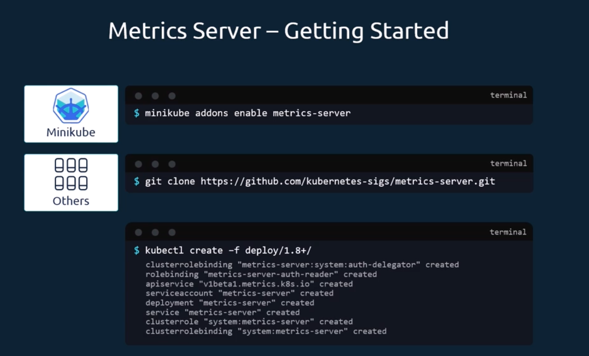
Once processed, cluster performance can be viewed by running the command kube control top node. This provides the CPU and memory consumption of each of the nodes. As you can see, 8% of the CPU on my master node is consumed, which is about 166 milli cores. Use the kube control top pod command to view performance metrics of pods in Kubernetes.
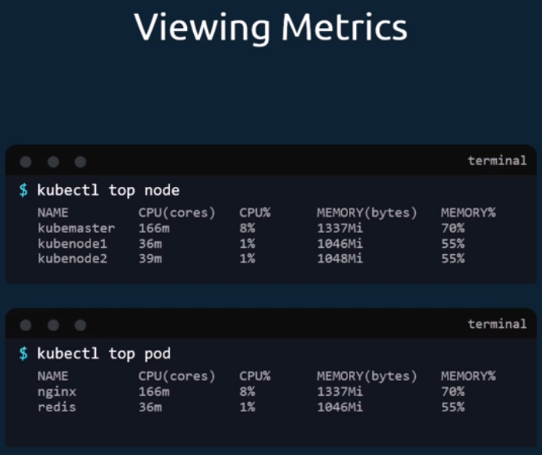
Managing Application Logs:
Let us start with logging in Docker. I run a Docker container called Event Simulator, and all that it does is generate random events simulating a web server. These are events streamed to the standard output by the application.
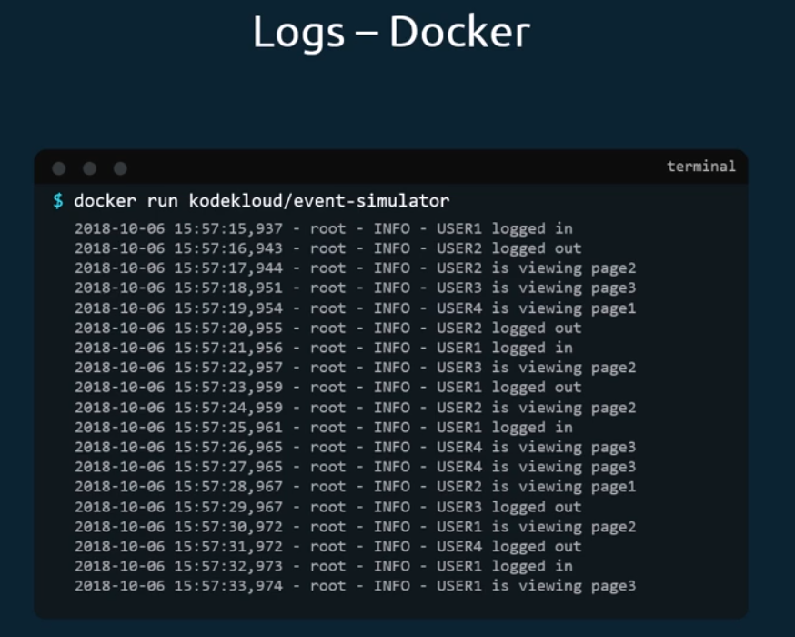
Now, if I were to run the Docker container in the background in a detached mode using the dash D option, I wouldn't see the logs.
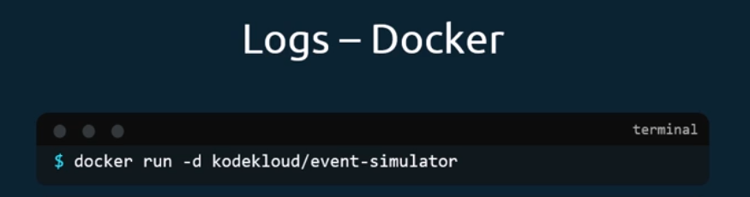
If I wanted to view the logs, I could use the docker logs command followed by the container id. The dash f option helps us see the live log trail.
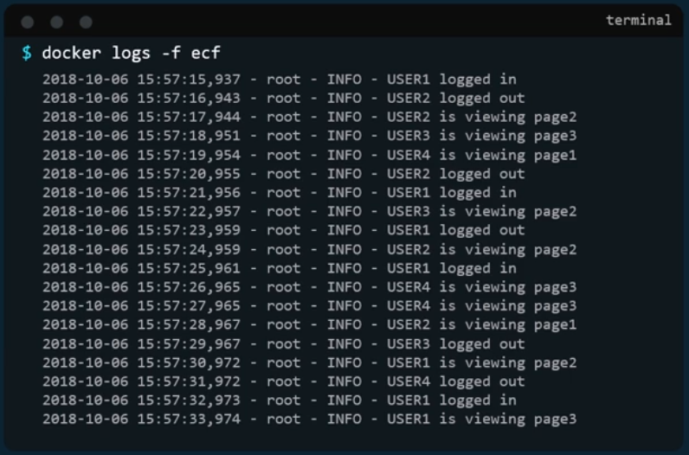
Now back to Kubernetes. We create a pod with the same Docker image using the Pod definition file. Once the pod is running, we can view the logs using the kube control logs command. With the pod name, use the dash f option to stream the logs live, just like the docker command. Now these logs are specific to the container running inside the pod.
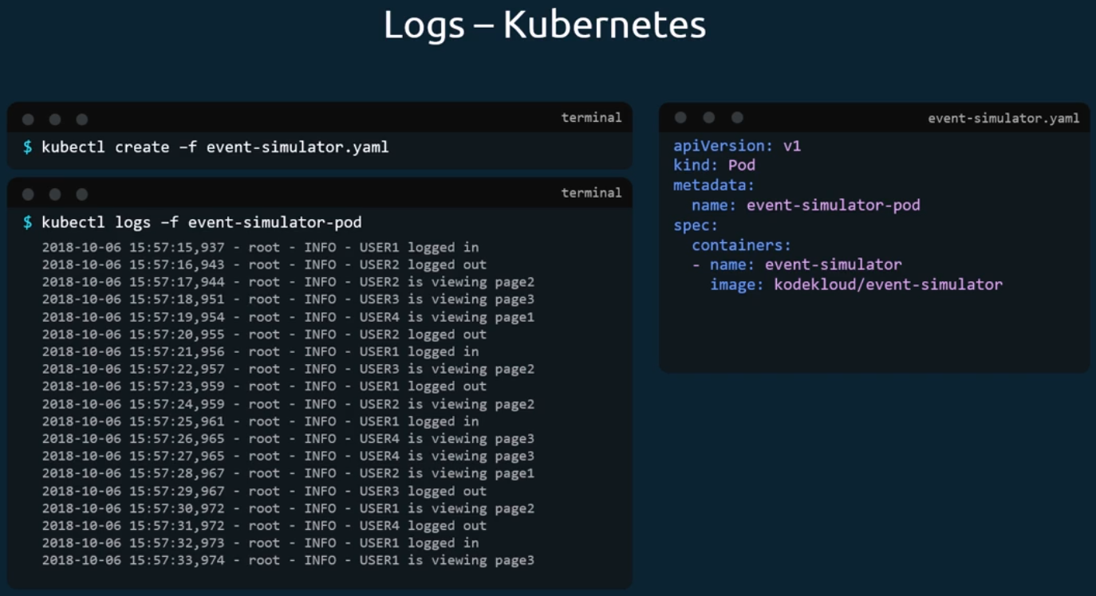
As we learned before, Kubernetes pods can have multiple Docker containers in them. In this case, I modify my Pod definition file to include an additional container called image processor. If you run the kube control logs command now with the pod name, which containers logs would it show? If there are multiple containers within a pod, you must specify the name of the container explicitly in the command. Otherwise, it would fail asking you to specify a name. In this case, I will specify the name of the first container event simulator and that prints the relevant log messages. Now that is the simple logging functionality implemented within Kubernetes. And that is all that an application developer really needs to know to get started with Kubernetes. And that is all you really need to know as part of the certification program.
